**Title:** Home Automation

**Description:**

We are attempting to create a home automation database management system in this work. To begin, we establish a database in which we will store the entries or bits of information about the house. “Home_Automation.sql” is the name of the database. We build three tables in this database, each with three to four rows and characteristics. There are three Entities in this assignment.

The three tables are:

1. Device control

2. Device location

3. Device status.

**Attributes & Entities:**

The attributes are dis_id, location, power_consumption, devices, room_name, longitude, network, data_usage. We used SQL Scripting Language to create certain commands for the SQL Creation. INSERT, SELECT, DELETE, UPDATE, GROUP BY, and join operations are implemented here. All outcomes are added here after execution.

1. **R Diagram:**

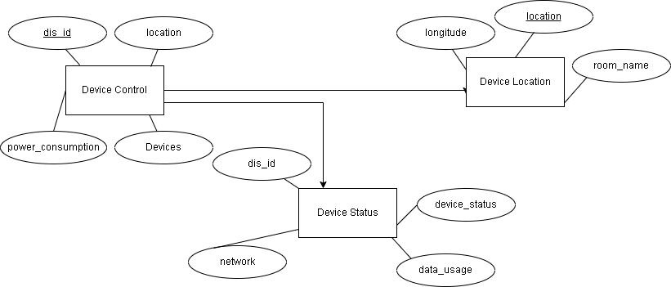

**Programs:**

**Insert Command:**

INSERT INTO `device_control`(`dis_id`, `location`, `power_consumtions`, `devices`) VALUES ('100056','room 1','low','samsumg galaxy s10');

INSERT INTO `device_control`(`dis_id`, `location`, `power_consumtions`, `devices`) VALUES ('67358','room3','high','Samsung Ac');

INSERT INTO `device_control`(`dis_id`, `location`, `power_consumtions`, `devices`) VALUES ('91358','room4','high','Hitachi Fridge');

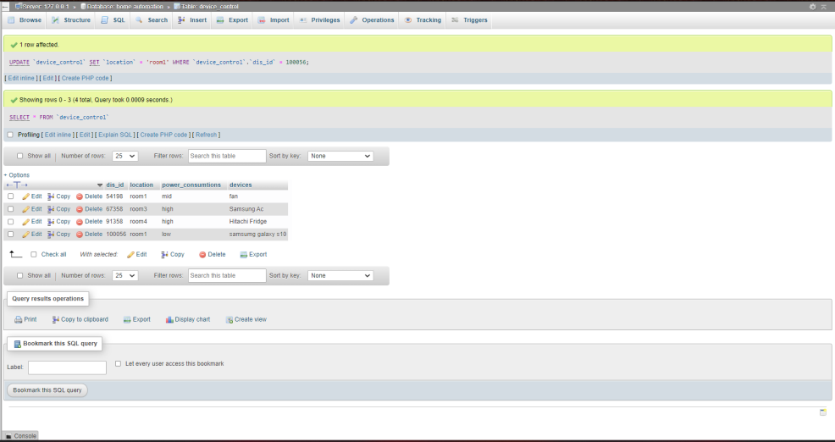

**Update Command:**

UPDATE `device_location` SET `room_name`='Living Room' WHERE device_location.room_name="Elon's play ground";

Before Update:

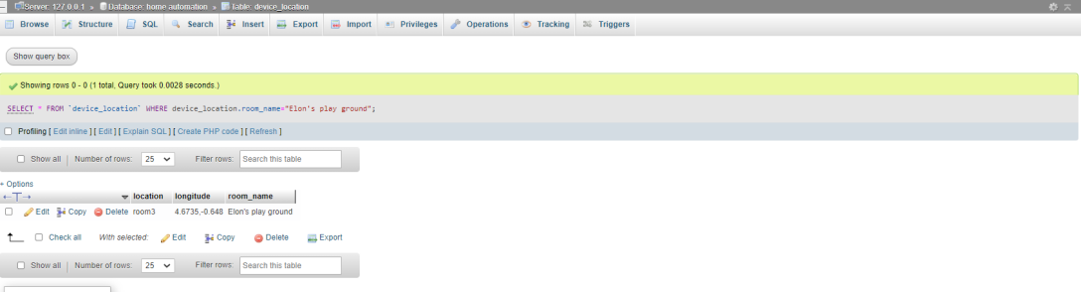

After Update:

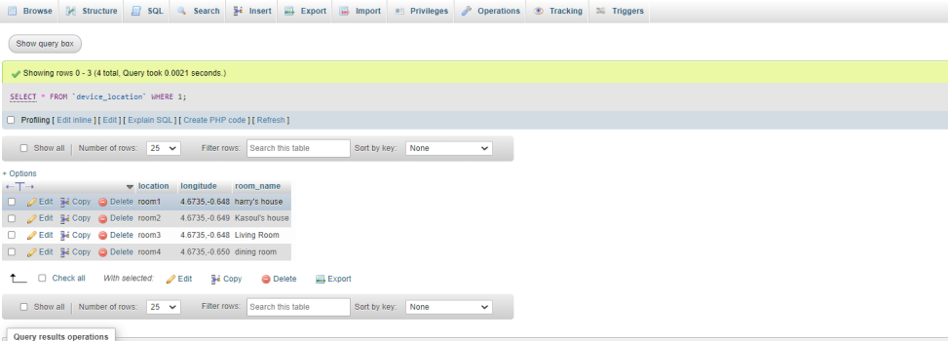

UPDATE `device_status` SET `network`='2.4 Ghz' WHERE dis_id=91358;

**Before Update:**

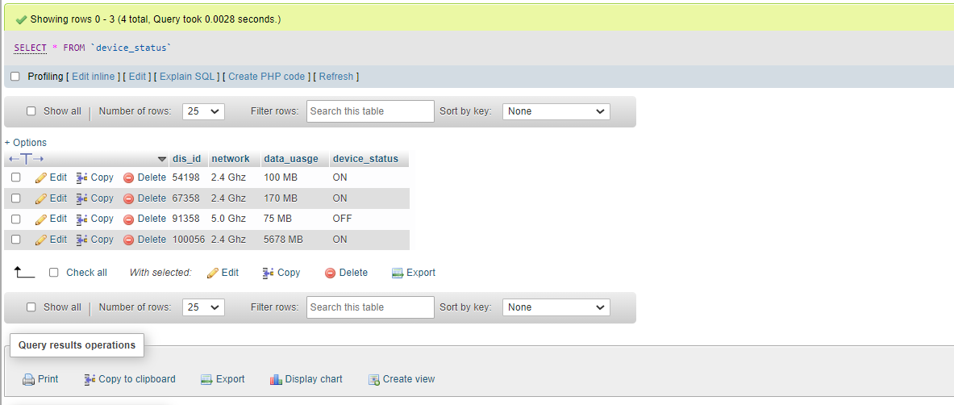

**After Update:**

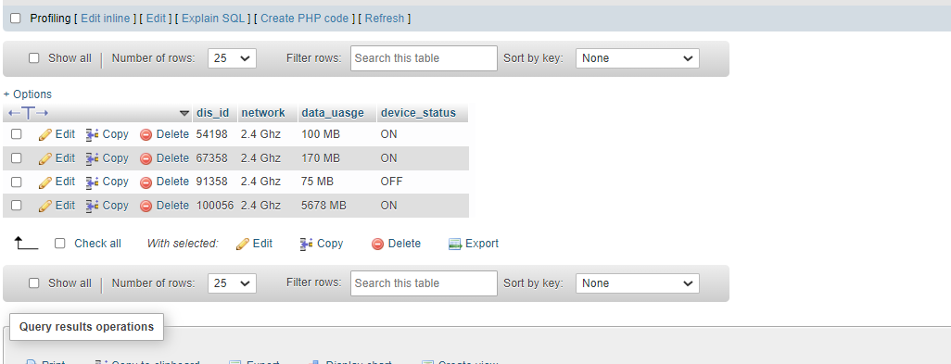

**Delete Command:**

DELETE FROM `statusdevices` WHERE `Date` IS NULL

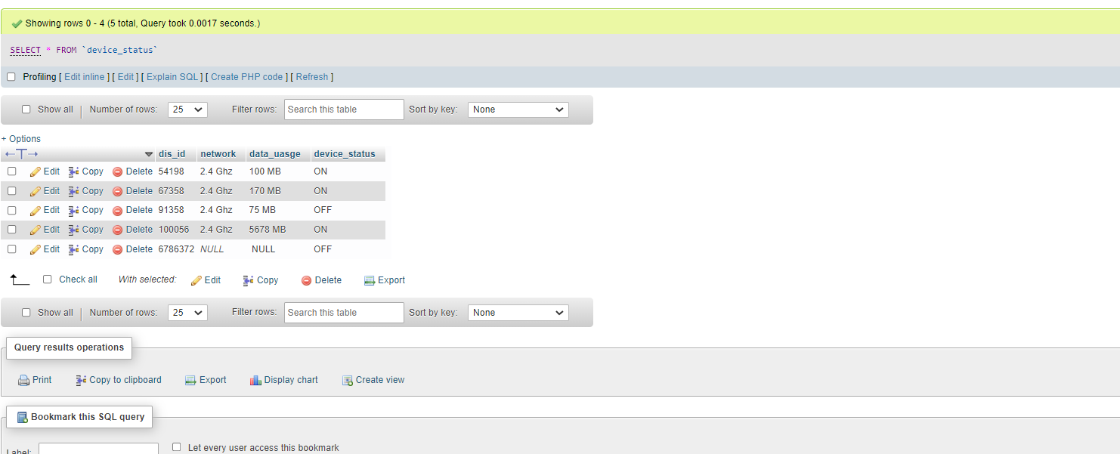

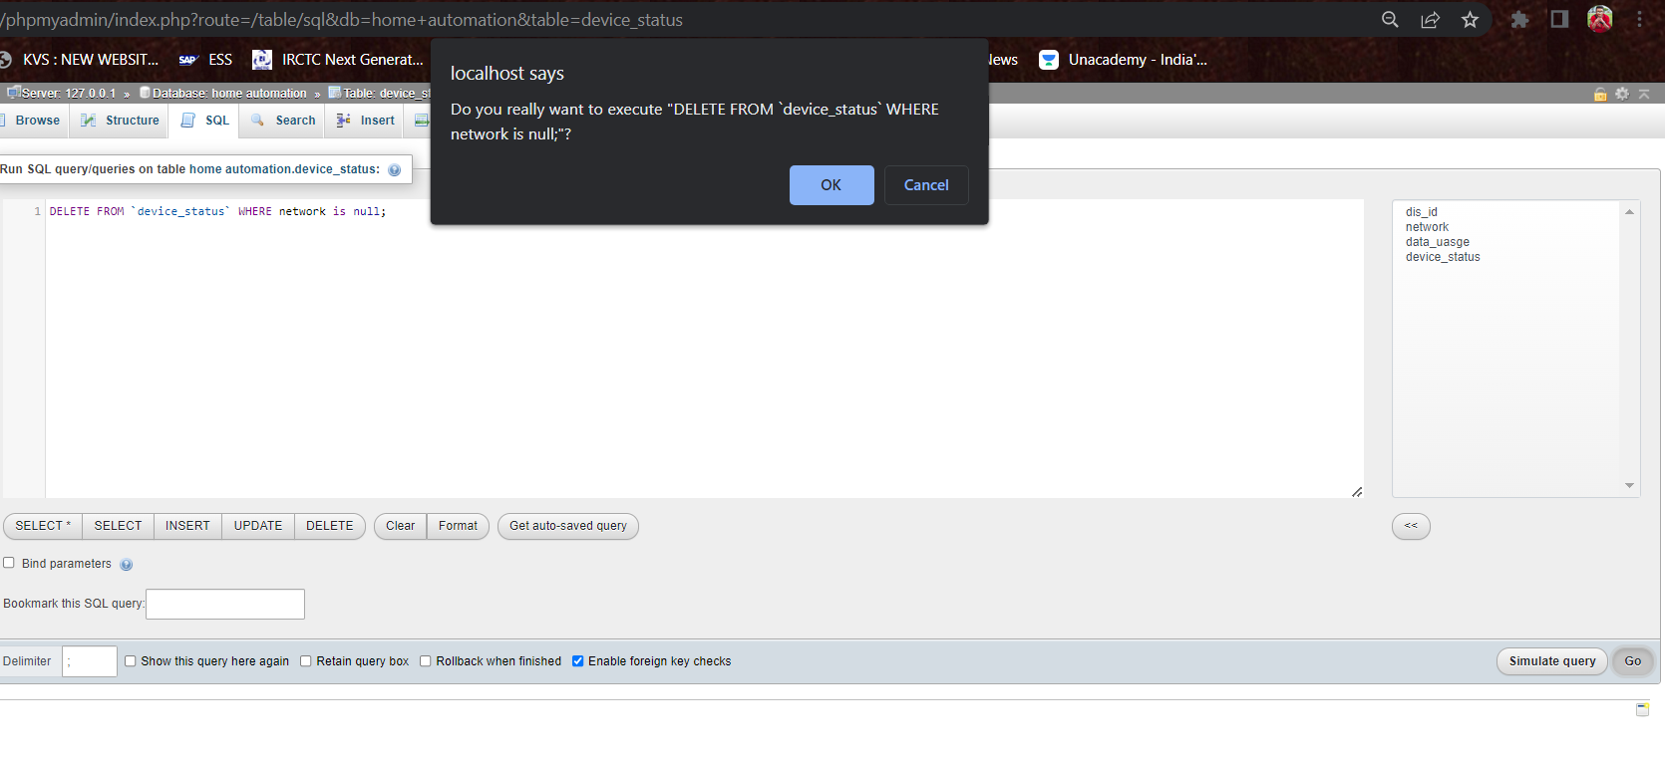

After Delete:

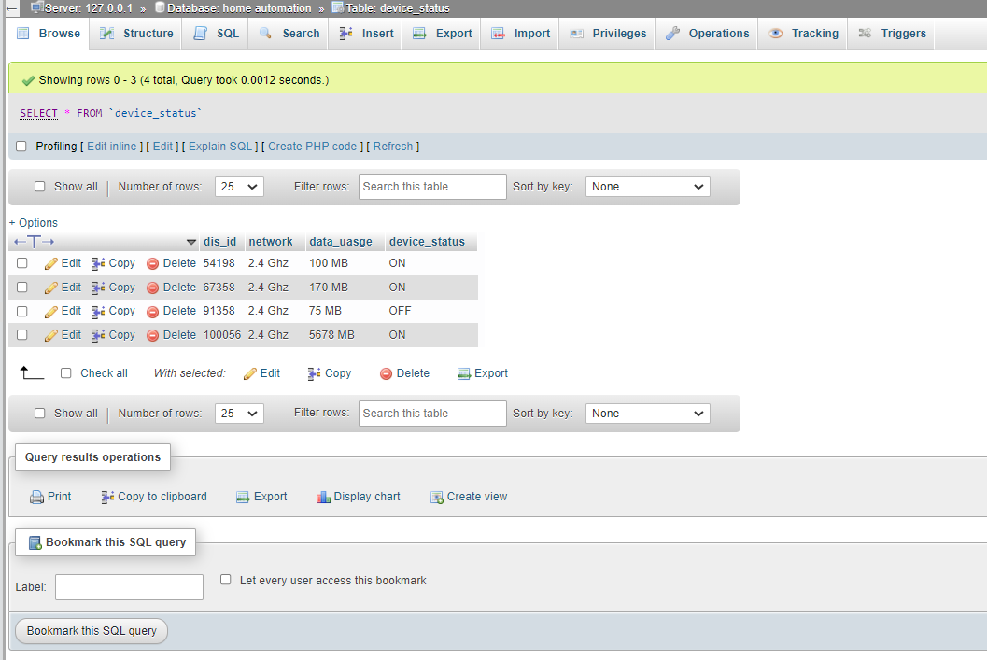

**Select Command:**

[SELECT](http://localhost/phpmyadmin/url.php?url=https://dev.mysql.com/doc/refman/8.0/en/select.html" \t "http://localhost/phpmyadmin/index.php?route=/mysql_doc) * FROM `device_control`

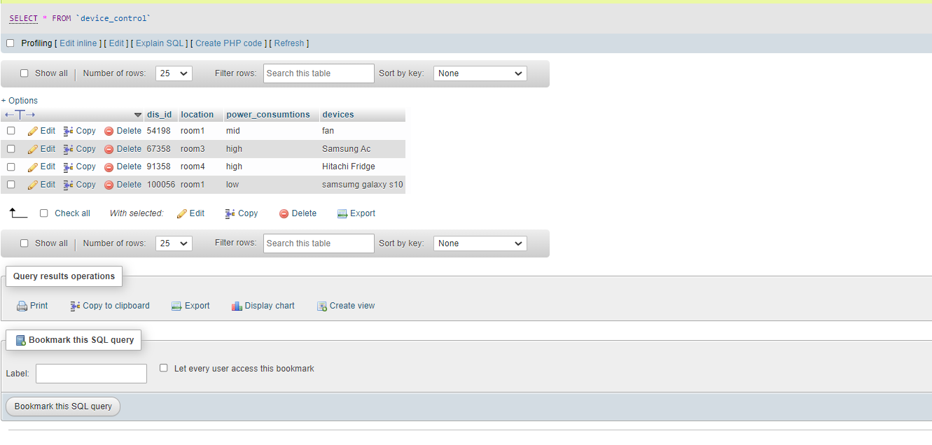

**Join Command:**

SELECT device_control.dis_id ,device_status.network, device_status.device_status, device_status.data_uasge from device_control JOIN device_status on device_control.dis_id=device_status.dis_id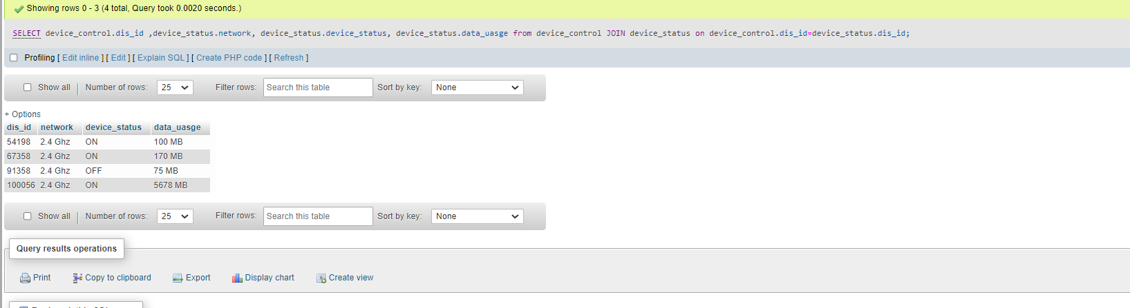

SELECT device_control.dis_id ,device_control.location, device_control.devices ,device_location.room_name from device_control JOIN device_location on device_control.location =device_location.location;

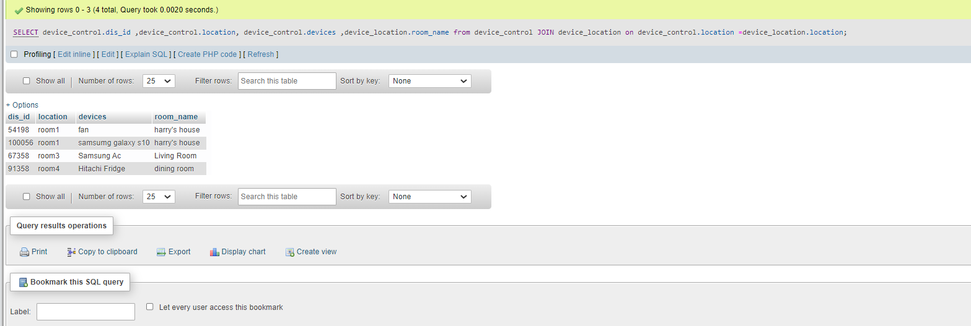

**Summary Command:**

SELECT device_status.dis_id, device_status.data_uasge ,device_status.network FROM device_status ORDER BY device_status.dis_id DESC;

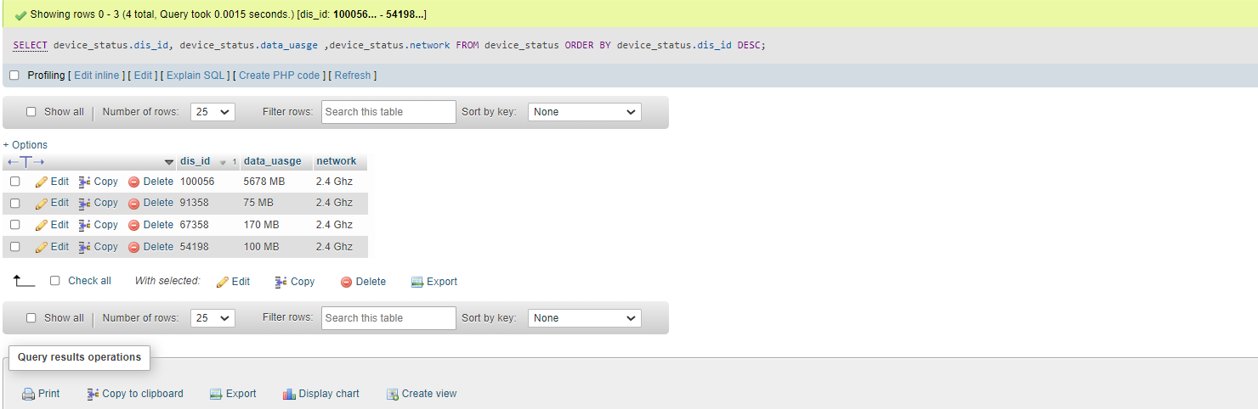

SELECT device_control.dis_id,device_control.power_consumtions,device_control.devices FROM device_control where 1 GROUP BY device_control.dis_id,device_control.devices;

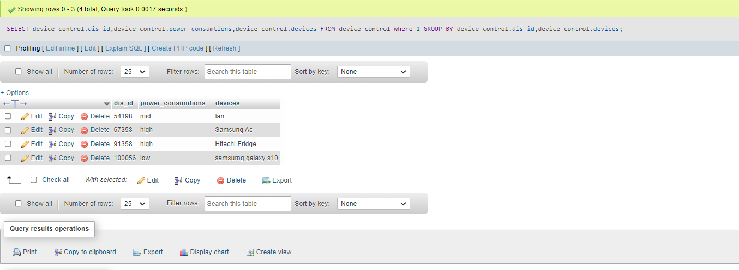

SELECT COUNT(device_status.dis_id) as "total_devices_on_2.4_network" from device_status where device_status.network="2.4 Ghz";

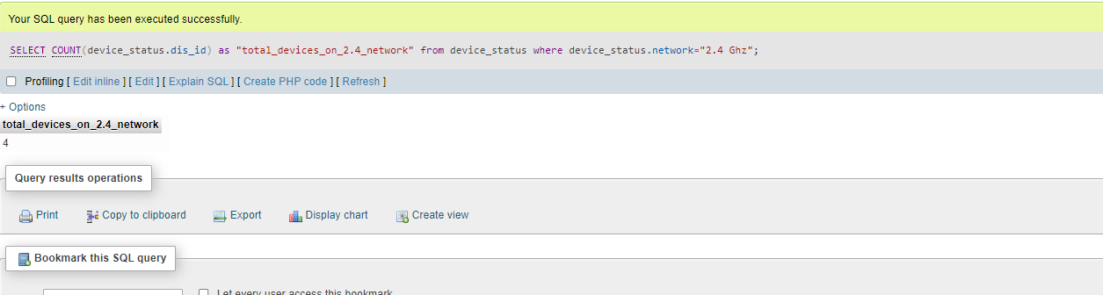

**Multi-Table Query:**

SELECT de.dis_id,de.network ,de.data_uasge,dc.power_consumtions,dc.devices from device_status de JOIN device_control dc on de.dis_id=dc.dis_id GROUP BY de.dis_id,dc.devices;

